

ALY 6980 Capstone - Winter 2026
Instructor: Valerie Atherley

Module - 10 Assignment: Individual Project Proposal: Draft Submission

Date: March 18, 2026

Submitted by,
Sumesh Chakkaravarthi Purushothaman

Abstract:

The Strategic Vendor Decision Support System project at Summit Global Consulting reports on its implementation progress. The project establishes a unified IT-sector vendor evaluation platform through its vendor data management system which combines two data governance methods with dashboard analytics. The system converts primary data into practical business insights which help organizations make procurement decisions while ensuring fair business operations through its two main functions of supplier diversity and operational accessibility.

Introduction:
Statement of the Problem
Healthcare organizations depend on third-party vendors to provide essential clinical services and operational support. The divided vendor data across different nonstandard spreadsheets and external databases creates major difficulties for executive teams to handle their operations. Organizations today use compliance-based methods to evaluate service quality instead of value-based indicators which creates an information gap. The absence of a common data standard creates extended vendor onboarding processes which result in market entry delays.

Purpose of the Study:
The primary goal of this initiative is to shorten the time to get products to market by helping Summit Global Consulting locate and rank high-value IT-industry vendors. The system evaluates suppliers through three main criteria which include 1) showing dedication to supplier diversity 2) proving their current business activities 3) providing simple methods for communication. The organization can develop logical vendor management decisions through its transition from reporting vendors passively to its implementation of organized vendor intelligence.
Approach:
The project implements a dashboard-based analytics system which enables non-technical business users to access its functions. The solution uses targeted data governance and schema standardization and interactive visualization to solve essential business problems instead of using advanced complicated predictive modeling techniques. The system creates a controlled database from multiple isolated spreadsheets which supplies data to an executive dashboard that displays a weighted ranking of potential business partners.

Literature Review

The rationale for the development of this project derives from five strands of literature:

- Adobor & McMullen (2014):

Adobor and McMullen (2014) demonstrate that businesses obtain higher value through their Supplier Diversity program which enables them to achieve essential market flexibility needed for business operations. The authors assert that organizations should regard supplier diversity as a strategic resource which becomes essential when their supply chains involve multiple vendors from different companies within a single industry. The research demonstrates how standard procedures and supply chain policies can maintain suppliers through their known processes to boost supply chain protection against disruptions.
The research provided by Adobor and McMullen also demonstrates the relationship between developing a methodology for rankings and categorizing supplier firms based on performance metrics. The sponsor named SGC established that the developed method must evaluate supplier performance through specific metrics which will create an empirical tool for analytical decision-making. The program meets its requirements because it uses diversity spending as a strategic resource to evaluate existing and prospective diverse supplier partnerships instead of merely tracking achievement percentages.
2. Whitfield & Landeros (2006):
The study conducted by Whitfield and Landeros in 2006 found that large organizations face three main challenges which prevent them from achieving supplier inclusiveness. The researchers discovered that organizations which maintain centralized and organized vendor information systems can use these systems to access purchasing organizations more efficiently. The systems provide organizations with access to better qualified vendors who can be chosen for essential procurement requirements.
This research proves that the project dashboard-centric analytics model successfully supports quick supplier decision-making processes. The sponsor SGC reported that purchasing delays occur because contact information for non-active vendors remains either outdated or insufficient. The platform solves the sponsor's transparency problems by establishing an analytics-based supplier inclusion governance framework that requires proof of both current contact details and business operations status.

- Obermeyer & Emanuel (2016):
The study conducted by Obermeyer and Emanuel in 2016 found that advanced analytics and machine learning systems provide healthcare benefits but require proper system understanding and operational controls for safe deployment. All healthcare analytics decisions must remain unbiased according to ethical standards which require complete transparency according to their assertion. The authors believe that analytics should support human judgment in all situations except for emergency instances when analytics should be used as a replacement.
The sponsor SGC used predictive analytics according to this insight when they applied their method in their proposal. The sponsor uses high-confidence analytics that users can verify through dashboard-based decision support systems instead of automated "black-box" models. The solution protects ethical standards through established processes which result in interpretable outcomes while maintaining ethical leadership accountability requirements which the sponsor needs for their auditable outcomes.
- Khatri & Brown (2010):
Khatri and Brown (2010) study data governance's organizational value through its complete framework which includes proper operational procedures and effective operational methods and appropriate personnel for producing trustworthy and accountable data. The authors contend that organizations need proper governance structures which will enable their analytical processes to produce trustworthy results. Their study shows that regulated industries should use data trustworthiness as the primary factor which governs their data handling procedures.
The proposed analytics platform supports these data governance principles by using standardized schemas and controlled categorization of reliable data sources. The sponsor SGC required vendors who provided unverifiable contact information to lose their access rights to the analytical platform because this measure protects data trustworthiness requirements. The governance-driven method guarantees that the executive team receives final analytical results which enable them to make secure and defensible procurement decisions.
- Davenport & Harris (2007):

Davenport and Harris (2007) study analytics maturity levels which they define as a requirement for organizations to embed analytics into their daily operations and leadership frameworks to achieve genuine competitive advantage. The researchers discovered that organizations need to obtain operational analytics which fulfill their particular business needs before they can successfully execute their plans. The research shows that users cannot work with highly complex models which do not establish compatibility with their operational processes.
SGC employs this dashboard design framework to create dashboards which deliver basic functions that non-technical users can operate. The sponsor, SGC, clearly discussed that simplicity and usability will be critical for stakeholders without technical backgrounds in making decisions regarding Vendor Partner Lists. The project serves as a strategic asset for organizational leadership through its focus on developing visualizations which all users can understand instead of constructing complex models.
Intersection with Data Governance, Ethics, and Social Responsibility
The deployed system uses standard schemas together with open accountability systems to achieve better data governance which supports its development from its initial design stage. SGC faced difficulties in evaluating vendor performance and their commitment to diversity because their datasets remained inconsistent with strategic objectives. The system defines all data elements through its strict requirements which include the need for verified contact information to establish essential data integrity and traceability.
The framework enhances corporate social responsibility through its ethical framework which transforms supplier diversity from a basic checklist requirement into an essential performance standard. Executive leaders use the interactive dashboards to access analytics that assist their decision-making process while maintaining unbiased and operationally fair procurement strategies.
Methods

Data Collection Instruments, Variables, and Materials
The process of data collection uses both internal proprietary materials and public databases as its data sources. The organization uses its internal tools to access vendor spreadsheets which contain historical procurement data. The organization uses public data from USAspending.gov and the Massachusetts state procurement portal and SDO directories as its external data sources. The process of data extraction includes the following specific variable requirements:
- Vendor ID: Name, verified contact information, and physical location.
- Industry/Sector: Filtering specifically for the Information Technology sector.
- Service Code: Classifications such as MEDICAL, VEHICLE, and FACILITY.
- Diversity Metrics: Supplier Diversity Office (SDO) commitment level (%).
- Operational Indicators: Contract type and current status of engagement.
Considerations on Data Governance
The analytical model requires strict data governance to function as its main supporting element. The data ingestion process establishes a standardized schema to harmonize classification categories across disparate sources. SGC has implemented a critical governance rule which requires all active contact information to be verified; two vendors who did not pass this check were removed from the database to maintain dashboard integrity and usability. The system guarantees that executive leaders make decisions based on trustworthy data which can be used for effective action.
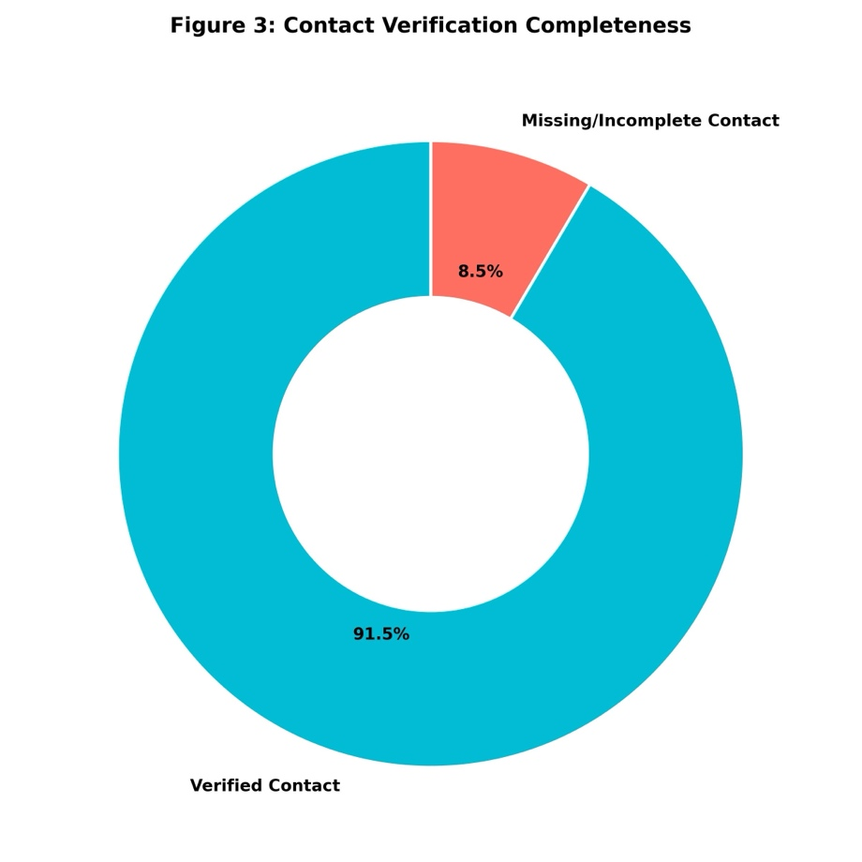
Advanced Exploratory Data Analysis Integration
The literature vision requires implementation of a comprehensive Exploratory Data Analysis (EDA) process which will analyze IT vendor distributions and SDO investment patterns. The analysis transformed raw spreadsheets into high-quality visual insights that map vendor distribution across Massachusetts agencies and highlight critical relationships between diversity percentages and total business spend. The graphical intelligence created the scoring algorithm logical requirements which discovered existing data biases before the dashboard started operation.
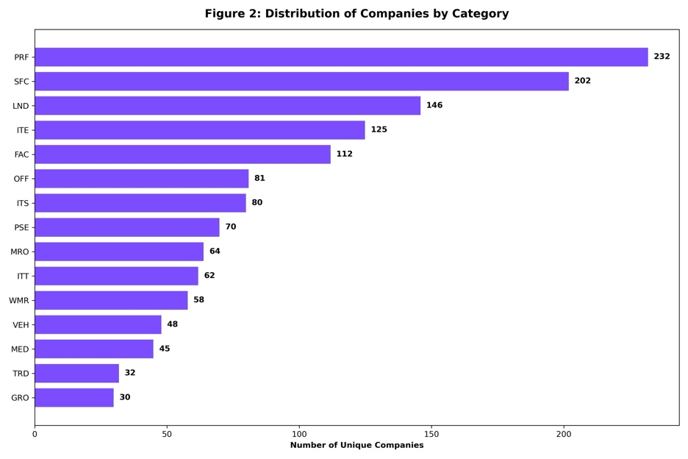
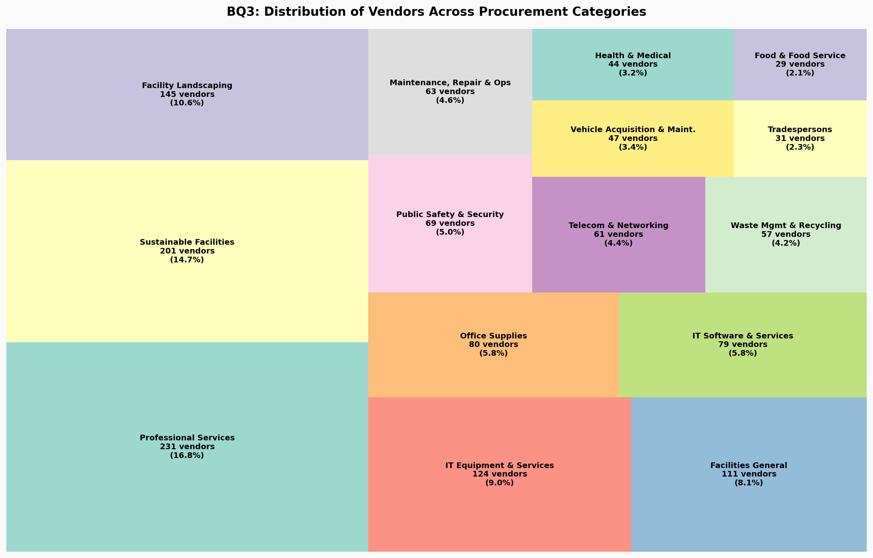
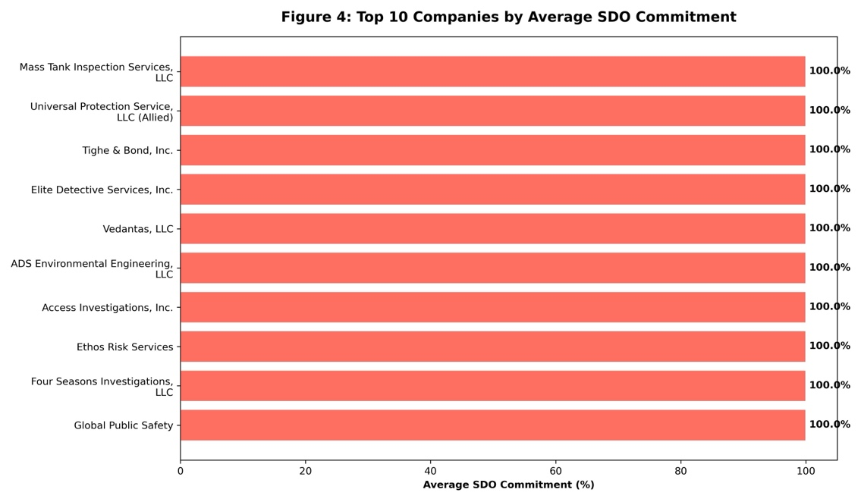

Interactive Dashboard Deployment
The interactive Plotly Dash dashboard was developed to function as the strategic decision support system which serves the primary objective that the proposal established. The dashboard uses the approved standardized dataset which displays its content through multiple tabs that show real-time Key Performance Indicators (KPIs) and vendor rankings which users can take action on. Business Development Managers can now intuitively filter IT-sector companies by total commitments which allows them to assess the market landscape instantaneously.
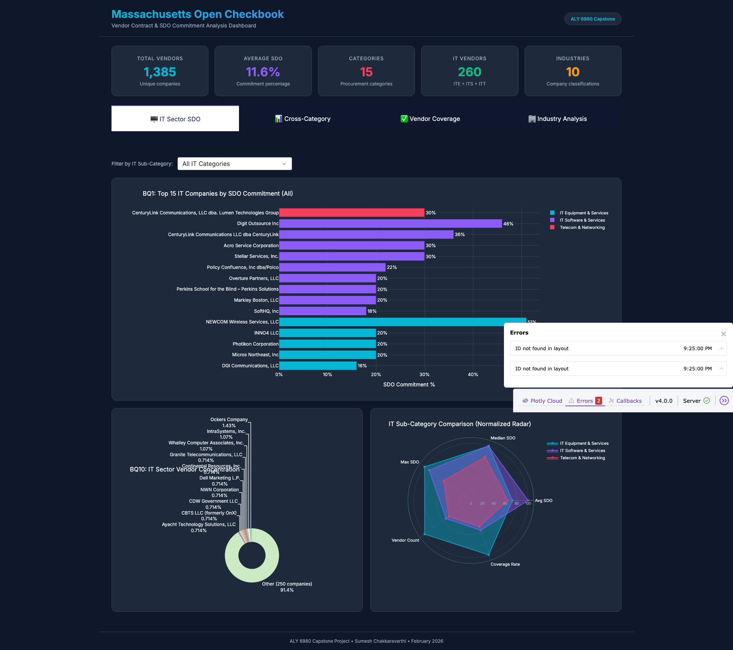

Vendor Scoring Model (Algorithm Calibration):
The analytical framework uses a weighted evaluation algorithm to assess the designated data which has been collected. The established framework distributes weight according to the strategic objectives which SGC has established.
- 40%: SDO Commitment Percentage.
- 30%: Normalized Addressable Spend.
- 20%: Active Contract Status.
- 10%: Contact Verification.

Methodology Overview (Process Flow):
The analytical lifecycle follows a governed process flow:
- Raw Vendor Data Ingestion: Internal and public data sources.
- Data Cleaning & Schema Standardization: Removal of duplicates and formatting standardization.
- Sector and Service Code Classification: Filtering for IT-sector appropriate technologies.
- Integration of Diversity and Performance Metrics: Combining disparate data into a singleintegrated database.
- Dashboard Visualization and Ranking Logic: Generating high-confidence reporting.
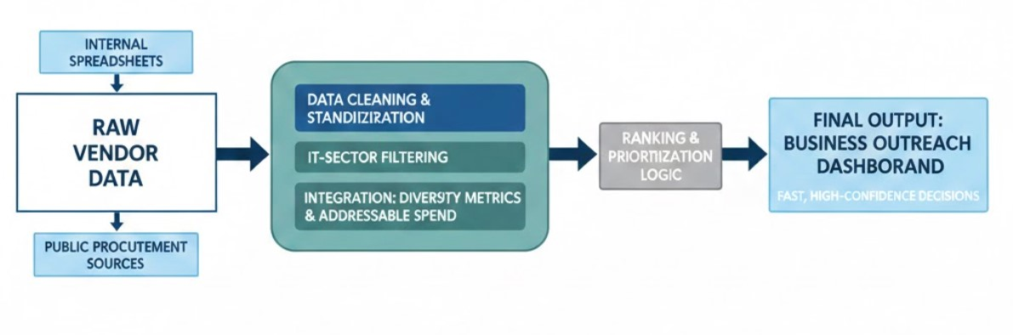

Preliminary Studies and Pilot Tests:
The first step of validation testing began with exploratory data analysis which examined the raw datasets for any existing structural biases or outlier data points before the scoring weights reached finalization. The Stakeholder Validation Survey was conducted among SGC business development and procurement personnel to assess their trust in data variables and their acceptance of the scoring methodology. The survey results provided input which was used to develop the dashboard usability functions and its governance procedures through multiple development cycles.

Risk Considerations and Bias Mitigation:
The organization faces several ethical risks which require resolution because the organization currently gives excessive importance to diversity metrics while neglecting the development of operational capabilities. The organization establishes flexible weighting systems because all vendor selection criteria require complete documentation. The system operates only as an advisory tool which human leaders use to maintain unbiased procurement methods that treat all operations equally.

Conclusion and Recommendations
The Strategic Vendor Decision Support System implemented by the organization unites multiple vendor data sources into a single operational intelligence system. SGC can make socially responsible purchasing decisions which are also efficient because the platform uses strict data governance and ethical transparency as its foundation.
Recommendations:
- Immediate Deployment: The complete dashboard should be used for all upcoming IT-sector procurement operations because it will help decrease onboarding time..
- Continuous Governance: The organization must keep its standardized data schema to achieve permanent data integrity and traceability.
- Iterative Weighting: The organization should assess its scoring weights on a regular basis to make necessary updates according to current strategic goals and stakeholder opinions.

Appendices

Appendix A: Project Timeline

Phase | Duration
Data Collection & Enrichment | 3–4 weeks
Cleaning & Standardization | 2 weeks
EDA & Weight Calibration | 2 weeks
Dashboard Development | 3 weeks
Survey Validation & Refinement | 2 weeks
Total Estimated Timeline | 10–12 weeks

Appendix B: Project Visuals
- Figure 1: Vendor Prioritization Process Overview
- Figure 2: Distribution of Companies by Category
- Figure 3: Contact Verification Completeness
- Figure 4: Top 10 Companies by Average SDO Commitment
- Figure 5: Interactive Plotly Dash Deployment

References:
Adobor, H., & McMullen, R. S. (2014). Strategic purchasing and supplier partnerships—The role of a supplier diversity program. Journal of Business & Industrial Marketing, 29(4), 263–272. https://doi.org/10.1108/JBIM-03-2012-0051
Obermeyer, Z., & Emanuel, E. J. (2016). Predicting the future—Big data, machine learning, and clinical medicine. The New England Journal of Medicine, 375(13), 1216–1219.
https://www.nejm.org/doi/10.1056/NEJMp1606181

Whitfield, G., & Landeros, R. (2006). Supplier diversity: Portals to prosperity? Supply Chain Management Review, 10(5), 16–23. https://www.scmr.com/article/supplier_diversity_portals_to_prosperity
Khatri, V., & Brown, C. V. (2010). Designing data governance. Communications of the ACM, 53(1), 148–152. https://doi.org/10.1145/1629175.1629210
Davenport, T. H., & Harris, J. G. (2007). Competing on analytics: The new science of winning. Harvard Business School Press

